THE NEEDS DOCUMENT

OF

THE GAME RENTAL PROJECT

1. INTRODUCTION

There are many gamers out there that would love to experience playing certain games but aren't able to since they don't have the means to buy them. If you were to introduce one of them to someone who owns the game that they want and is willing to rent it out to him for a price he can afford, he'd be thrilled! Actually both would be glad since the one renting will finally have the opportunity to play the game he wants and the one renting it out will make some extra cash.

This project aims to provide opportunities for gamers to play games they wouldn't normally be able to play and also for them to make profit by creating an application that somewhat simulates the type of transaction that I've mentioned above. An application where gamers can rent games from other people.

1. MISSION STATEMENT

The mission of this project are the following:

* To connect people who are willing to rent out and rent a game.

Some people are willing if not more than willing to rent out a game that they own or rent a game from another user. But the problem is that they are having a hard time finding another person who shares the same interest. One of the purposes of this project is to connect these types of people and provide them a place to conduct their transactions conveniently.

* Opportunity for gamers to save money.

Every year, there are tons of anticipated video games that are being released. And the majority of these games are only available when purchased. Purchasing a video game can cost a lot especially if the game is newly released. By only renting the game, this creates an opportunity for gamers to save money since the total money spent on renting a game is significantly lower than buying it.

* Opportunity for gamers to play games they can't afford.

There are times where a gamer’s budget is tight which results in not affording to buy the game he/she is waiting to be released. This project aims to give an opportunity to those gamers to experience the gameplay of those games that seems to be out of their reach, and the gamer gets to experience this with only minimal spending.

* A way for video game owners to make extra money.

There are people who own a game or a collection of games and have nothing to do with them. It may be because they already finished the game, maybe they don't have the time to play, or maybe they don't feel like playing the game any time soon. But one thing is clear, it would be a waste to spend money on a game and just have it lay around collecting dust. One of the purposes of this project is to provide them with a platform where they can earn money by allowing them to rent out a game that they own to another user.

1. TECHNICAL OBJECTIVES

| **Technical Objectives** | **Performance Measures** |
| --- | --- |
| Create an app that allows users to register an account. | Presence of a registration and login module.  Users must not be able to login without registering  Users must only be able to login only with correct credentials  Users must be able to log in and log out of the system |
| Create an app that allows users to browse video games that are available for rent. | Presence of an user interface with the list of the available games for rent.  Presence of a search bar to allow the user to filter the item he/she is looking for  The app must only show results regarding the available video games at the time.  Users must be able to view the specification of a specific item  Users must be able to post a question or a review regarding a specific item |
| Create an app that allows users to post their used video game collections up for rent. | Presence of a game recording module.  The app must only accept game items  Users must be able to post a picture or video of the item  Users must be able to post a specification of an item |
| Create a convenient transaction process for payment between the users. | Presence of a simple ecommerce module.  Non-registered users must not be able to make a transaction  The app should provide different payment methods for the transaction  Users can only complete a purchase with a valid payment credentials  Completed transactions should generate a receipt  Transaction code in each receipt must be unique.  Canceled transaction must void the receipt. |

1. SCOPE AND LIMITATIONS

This project allows users to access a game rental service by using a mobile application where the users can either put up a video game that they own for rent or rent a video game owned by another user. The system does not offer the option to purchase games and is only limited to game rentals.

Being part of any form of scam doesn’t hold the company accountable, users are expected to be vigilant. The project does not assume responsibility for the damage to the game when the game is not in the company's hand. After a certain amount of time, a transaction will become irreversible. This project is expected to complete in 2 months.

CONCEPTUAL FUNCTIONAL MODEL

OF

THE GAME RENTAL PROJECT

Technical Objective 1: Create an app that allows users to register an account.

OPERATIONAL SCENARIO:

The user visits the mobile app using a mobile device. On the front page, the user can see a button called “Login”. When the user presses this login button, a new page called the “Login Page” is presented. This page contains a form asking for a username and password together with a “Login” button. The user types their information in the form and the system will verify their information and if the login is successful, they are transferred to the “Dashboard”, otherwise, they will be redirected back to the “Login” page with an error message. In this dashboard, they are presented with a “Logout” button that logs them out and transfers them back to the front page.

If the user does not have an account, they are presented with a button that takes them to the “Registration” Page. In this page, they provide a username and password. When done registering, they are taken to the “Dashboard” page as logged in users. If there is an error in the information they provided, they will be redirected back to the “Registration” page.

Technical Objective 2: Create an app that allows users to browse video games that are available for rent.

OPERATIONAL SCENARIO

After logging in successfully, the user is provided with the home page of the app. This allows the user to browse directly in the home page for video games that are available for rent. Also, there is a presence of a search field located at the top alongside with its search button. In this field, the user can input any information regarding the item that he/she is looking for. When the “search” button is pressed, the app will filter out the items and only show the matching search results. Additionally, the user must be able to view the basic details of a specific item. Once the user pressed the chosen item, complete details of the item will be displayed. Also, the user will be able to post inquiries and see the reviews regarding the item.

Technical Objective 3: Create an app that allows users to post their used video game collections up for rent.

OPERATIONAL SCENARIO:

There is a presence of a sidebar menu located at the home page which contains two buttons. The first one allows the user to upload a picture or video of the item to be posted. Once done uploading the required attachments, he/she will be redirected to a form which requires the user to enter the specific details of the uploaded item. After filling up the form, the user will be able to press the “Post this Item” button to verify the item. Once it’s verified by the system, the item will be added to the listings. In case the user uploaded a different item or not related to games the item will not be included in the system and the user will be notified. The second button allows the user to view his/her all uploaded listings and check whether the item is rented out by other users or available for rent.

Technical Objective 4: Create a convenient transaction process for payment between the users.

OPERATIONAL SCENARIO

After the user clicks on an item, the page where the user can see more details about the item contains another set of buttons which is the “rent now” button and the “add to cart'' button. When the user clicks the “rent now” button, a pop-up message will appear. The pop-up message will ask the user to confirm the action, and if the user does confirm, they will be redirected to a page containing the details of the item that the user will rent. Alongside these details is a set of options containing different types of payment method that the user can choose from. After the user picks on a specific payment option, they will be provided with a form asking for the payment details needed in order to complete the transaction.

System Activity

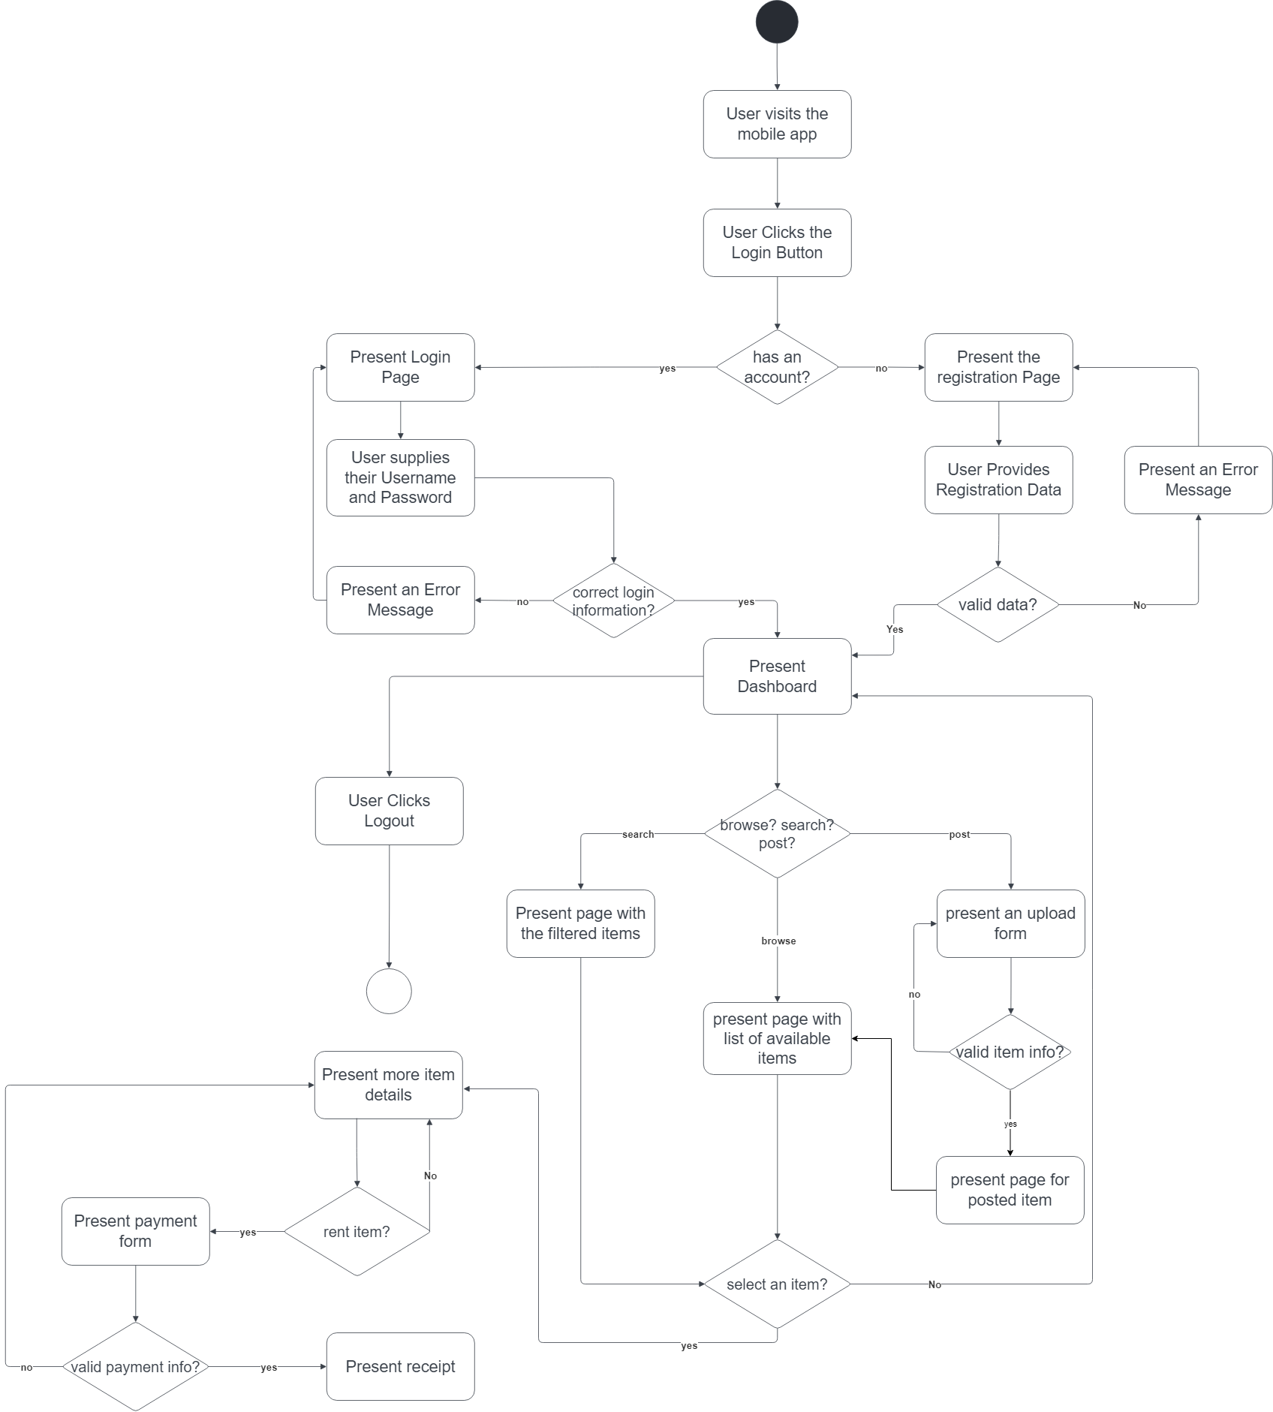

ERD

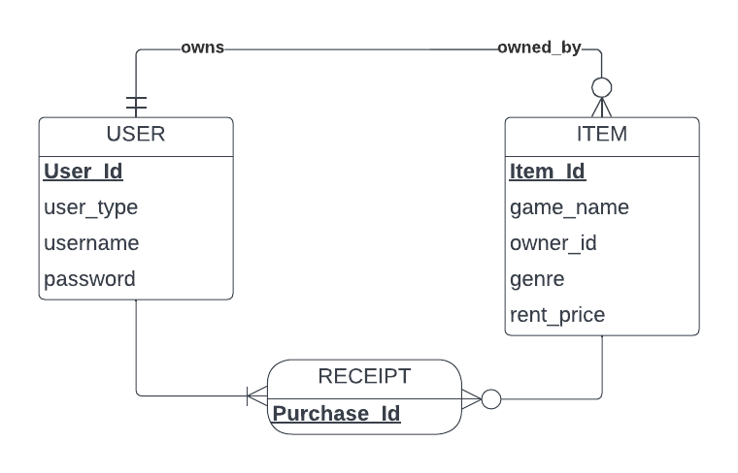

Use-Case Diagram

